**Youtube视频放置到官网步骤**

1. **复制嵌入代码**

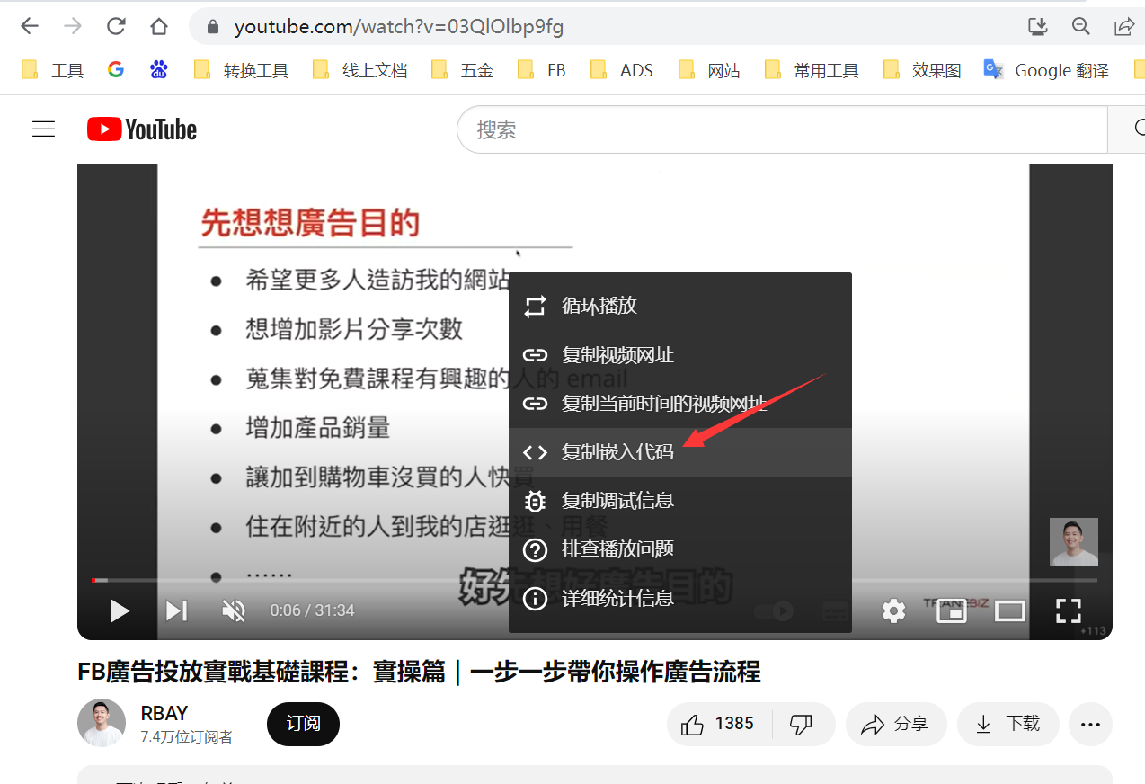

**嵌入代码**

<iframe width="853" height="480" src="**https://www.youtube.com/embed/03QlOlbp9fg**" title="FB廣告投放實戰基礎課程：實操篇｜一步一步帶你操作廣告流程" frameborder="0" allow="accelerometer; autoplay; clipboard-write; encrypted-media; gyroscope; picture-in-picture; web-share" referrerpolicy="strict-origin-when-cross-origin" allowfullscreen></iframe>  
  
**备注：放红色字体部分的链接即可**